Lab Session by Suman

1. Program to reverse a number

Input:

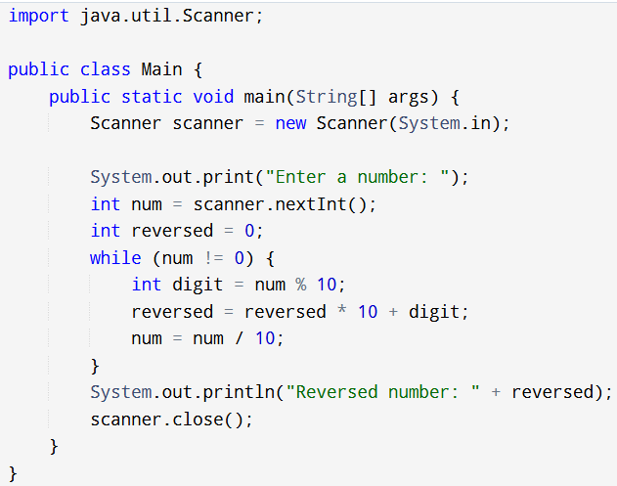

Output:



1. Java Program to check if a number is a palindrome

Input:

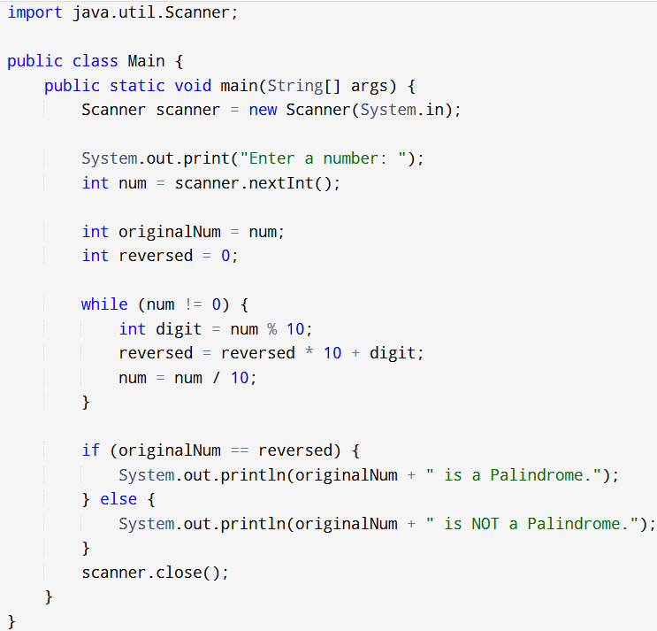

Output:



Create a java Program for a simple calculator

Input:

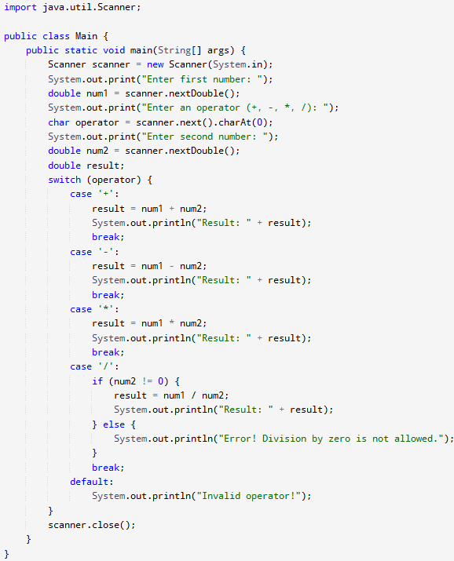

Output:

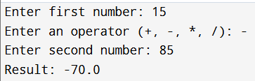

1. Create a java Program to check if a number is prime

Input:

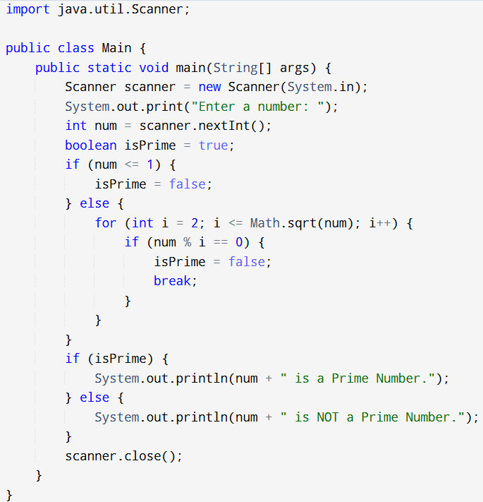

Output:

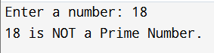

1. Program to check if a number is an Armstrong number

Input:

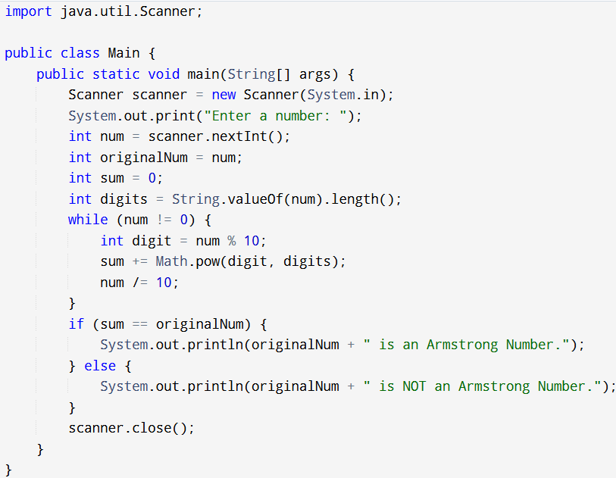

Output:



1. Program to Find the Largest of Three Numbers using ternary operator

Input:

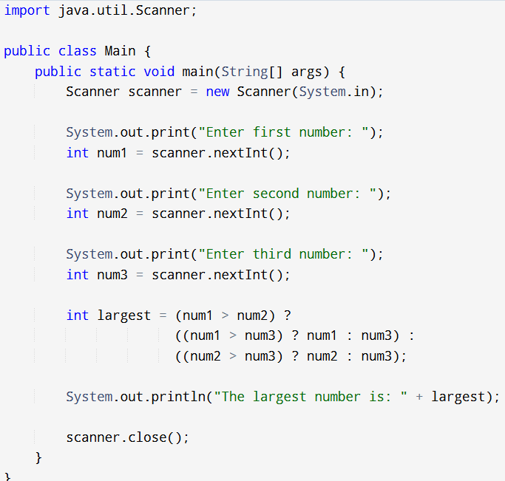

Output:

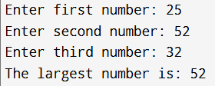

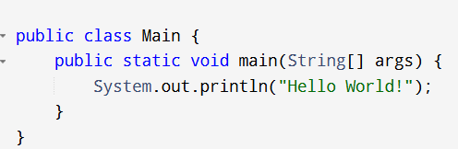Input:

Output:

1. Write a java program to print hello world.

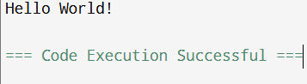

1. Java Program to take input from the user and print the sum of two

numbers.

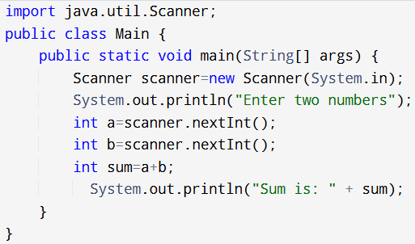Input:

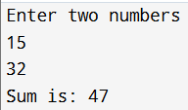Output:

Create a java program to check whether a number entered by the user is even or odd.

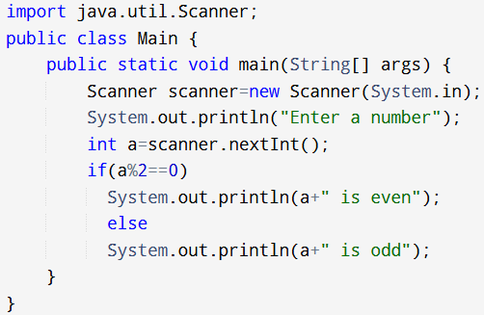Input:

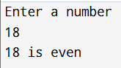Output:

1. Create a java program to print the average and sum of 5 numbers

entered by the user.

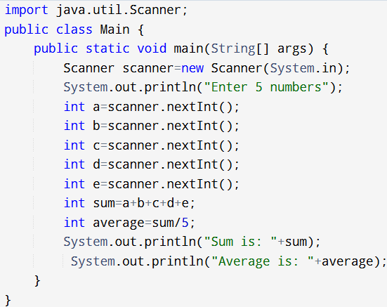Input:

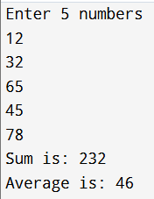Output:

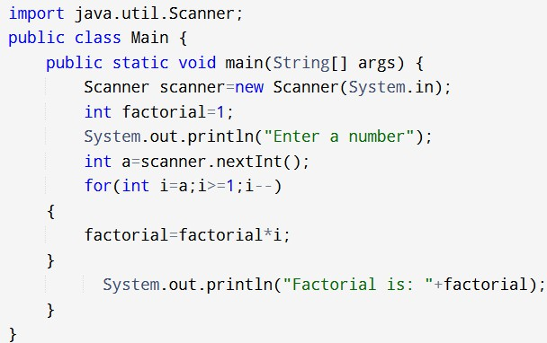Input:

Output:

1. Program to calculate the factorial of a number.

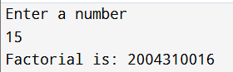

1. Program to print Fibonacci series up to n terms.

Input:

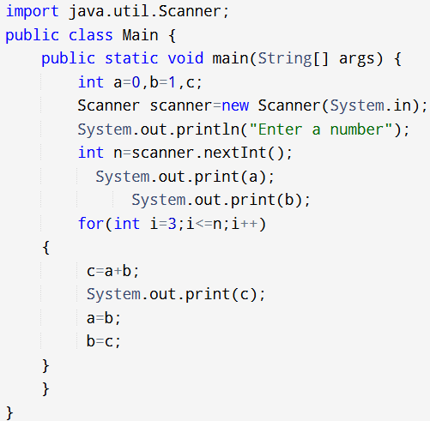

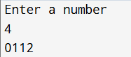Output:

1. Write a java program to print hello world.

Input:

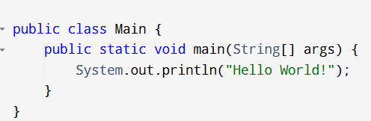

Output:

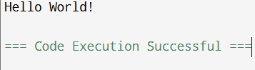

1. Java Program to take input from the user and print the sum of two numbers.

Input:

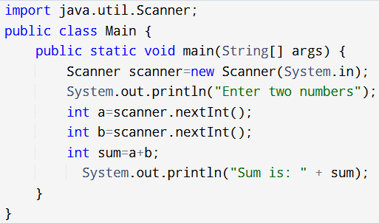

Output:

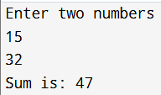

Create a java program to check whether a number entered by the user is even or odd.

Input:

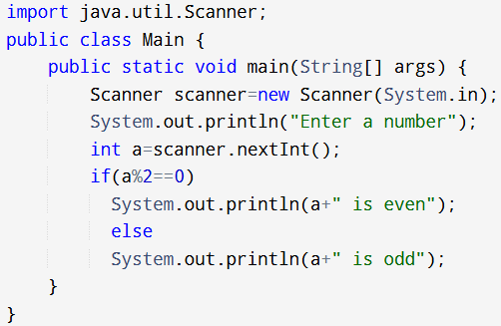

Output:

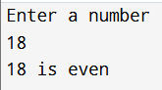

1. Create a java program to print the average and sum of 5 numbers entered by the user.

Input:

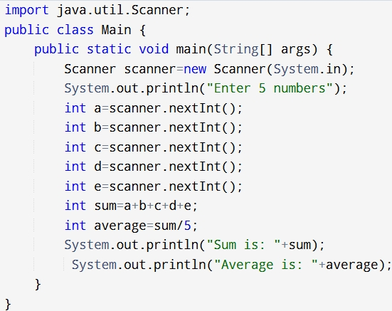

Output:

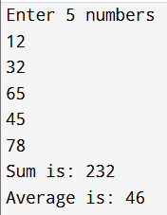

1. Program to calculate the factorial of a number.

Input:

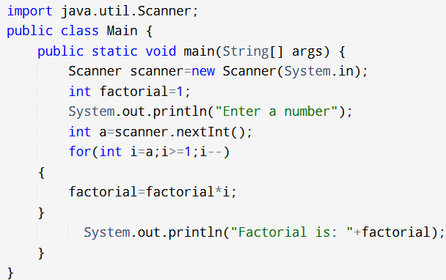

Output:

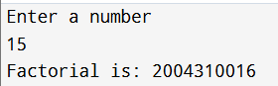

1. Program to print Fibonacci series up to n terms.

Input:

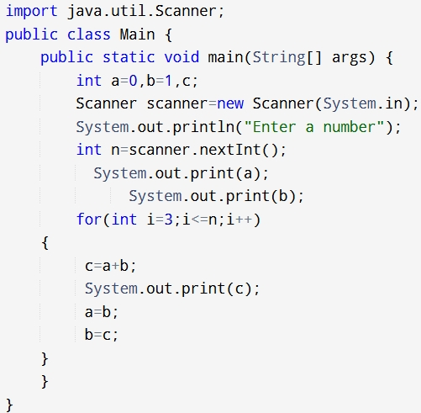

Output:

